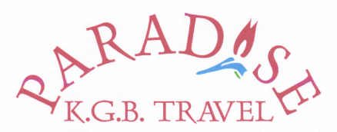
Tour | Day | Price pp
Horse Riding Patara - Two and a half hour's riding through the Village on to Patara Beach | Everyday | £35
Jeep Safari - Drive through the mountains, lunch at Saklıkent, finishing with a swim at Patara Beach | Everyday | £30
Canoeing - Canoe down the river Essen in Canadian canoes, finishing Patara. No experience required. Lunch included | Everyday | £24
Kekova and the Sunken City - Drive along the coast to Kekova and then enjoy lunch on a boat whilst viewing the sunken city | Friday | £28
Fethiye Market - Bargain hunting at Fethiye's large open air market, followed by a drive to Olu Deniz. Turkish bath an optional extra | Tuesday | £25
Tlos and Saklıkent - Visit the historical ruins at Tlos, then lunch at Saklıkent Gorge where you can walk up the river, rafting on optional extra | Wednesday | £25
Boat Tours - Spend a relaxing day traveling by boat around Kalkan Bay, swimming in the coves and small bays and enjoying a delicious meal cooked on board | Everyday | £18
Sunset Tours - Evening boat tour with dinner provided - watch the sun setting into the sea | By arrangement | £18
Quad biking - Duration 2 ½ - 3 hours morning or afternoon. An increasingly popular activity, exciting and energetic, this takes place at the famous Patara beach | By arrangement | £40
Turkish Bath - Duration 2 - 2 ½ hours. Included: Loofah massage, soap massage & oil massage | Everyday | £59
Xanthos and Islamlar - 4.30 pickup we drive to Xanthos, ancient capital city of the Lycians, arriving as the sun is setting. After, we drive up to Islamlar which is an authentic example of a Turkish village. Then, for supper, we visit Mahmuts trout restaurant, one of the best restaurants in Islamlar | Saturday | £30
Most tours start at nine o'clock and return by 6pm, horse riding is either morning or afternoon
Other tours can be organized by arrangement, please see Damla Kaplan for ideas and prices

