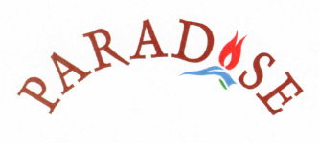
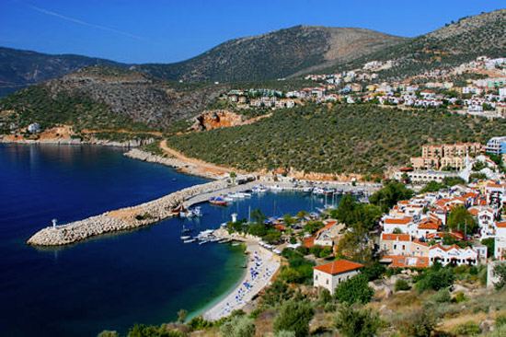

RESTAURANT & CAFE BAR
Please call the Restaurant on
(009) 0530 521 89 00

