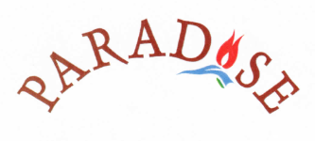
USEFUL INFORMATİON

Water – We are lucky to have a mains supply of water from the mountains here, but as we sometimes have to rely on water from storage tanks in the summer we advise you to drink bottled water.
Tap water is absolutely fine for use in the kettle or for cooking.

Elektricity – The voltage is the same as in Europe so appliances can be used safely with an adapter. We do sometimes experience power cuts in the height of summer, but these rarely last long.

Toilets – Another advantage of our location is that we have mains drainage here so toilet paper can be put down the toilet, unlike in Klakan where it must be put in the bins provided.

Telephones – Most mobile phones work here in Turkey and the reception is good.
0090 is the code for Turkish numbers
0044 for the UK
in both cases, omit the first 0 of the number being dialled
Texting is relatively cheap but if phoning the UK, using the land lines at the Post Office in Kalkan is by far the cheapest method.

