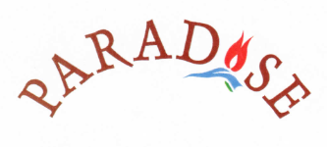

Paradise Bar
Our poolside bar is open throughout the day and evening for drinks and snacks for guests from any of the apartments. You are welcome to use the big pool facilities there including the shaded Ottoman seating where you can relax in the heat of the day. Drinks can be put on your bill and your bill can be checked Daily, then paid for at the end of your stay.

Paradise Restaurant
Breakfast, Lunch and Dinner are available at the Paradise Restaurant, situated on the roof terrace beside our office. Enjoy the magnificent views of Kalkan and the Bay or you can order food to be enjoyed at your poolside, villa or apartment – our staff will deliver it to you. Menus are available at the restaurant or Office and if there is anything special that you would like to order, just tell us and we will do our best to provide it!

Weekly Barbeque
Every Wednesday we hold a BBQ at the restaurant where grilled meats, mezes and salada re offered, bookings for he BBQ should be made by Wednesday morning at the latest please.

